Regarding the content of next Sunday's treasury workshop, based on some observations I made while assisting Carole St-Denis, I think we should also include explanations about issuing T4A slips and our method for producing them.

I have detailed the various points to be taken into consideration below. We should probably find time to discuss this together in person before putting the information below in writing.

1) First, our legal obligations under the laws of this country.
https://www.canada.ca/fr/agence-revenu/services/impot/entreprises/sujets/retenues-paie/remplir-produire-declarations-renseignements/t4a-information-payeurs/feuillet-t4a.html
- Remind residents of this country that they must declare all income on their annual tax return, including income from a T4A slip.
- Remind them that the church is not an individual, but an entity with obligations.
- Remind them that receiving a donation from an individual (even $1 million) is NOT taxable, but that a church or company that GIVES an amount to an individual provides that individual with taxable income.
- Remind them that a $1 million building construction project, if funded by a church, potentially means that the government has paid (through tax credits) more than half of it!
- Remind them that an expense for "free services" rendered to the church is not eligible for an official donation receipt.
- Remember that receiving a T4A slip is not the end of the world: the individual can declare expenses associated with this income and thus reduce the amount that is actually taxable.
- Also remind them that we are not looking for accuracy: our approach is to demonstrate to the government our due diligence in identifying such payments made to individuals without supporting documentation.

2a) Our legal obligations prompted the Federation to include this type of expense in the chart of accounts of the new Churchpal software in 2020.
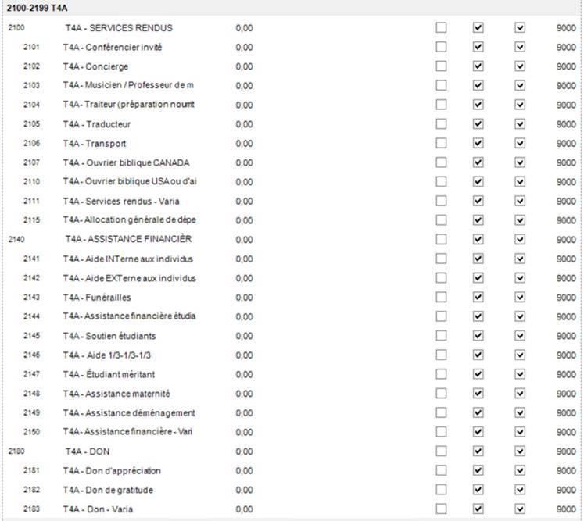

2b) Our legal obligations prompted the Federation to produce an internal PDF form in 2016 entitled "Declaration of payments to individuals WITHOUT SUPPORTING DOCUMENTATION" to be completed by church treasurers as supporting documentation.
https://sdaqc.org/private/wp-content/uploads/2018/10/Formulaire_Declaration_debourse_individus_T4A_2016.pdf

2b) Our legal obligations have also prompted the Federation to create an Excel file (accessible in the private area reserved for treasurers on the old website - password: PAYMENTS) allowing treasurers to consolidate the information from all these declarations into a single file to be sent to the Federation around mid-February of the following fiscal year.
https://sdaqc.org/private/wp-content/uploads/2018/10/Declaration_Payment_Individus_T4A_template_Excel2003.xls

THE PROBLEM: Few treasurers (in my opinion, 33%) use the PDF form, and even fewer use the Excel file (in my opinion, 10%).
- The difficulty in completing the returns stems (in my opinion) from the requirement to obtain the individual's Social Security Number WITH THEIR SIGNATURE: a bit inconvenient + easily accessible form?
- The difficulty in completing the Excel file stems (in my opinion) from the redundancy of having to MANUALLY RECOPY all the information entered manually on the declarations into the Excel file: it takes time☹ AND are there any consequences if the treasurer does not do so?☹ AND is it easily accessible and easy to complete?

3) Currently, we REMOTELY inspect payments made to individuals with rounded amounts in Churchpal.
- We know that treasurers can enter these specific disbursements in Churchpal without supporting documentation in accounts other than those (mentioned above) reserved for this purpose.
- Our problem is that we do not know whether or not these types of disbursements are accompanied by supporting documents: the amounts are rounded, so it seems a little suspicious. We suspect that the money was paid without supporting documents (with the expectation of obtaining them later).
- Sometimes, the check is not made out to the person who will ultimately receive the money because the recipient does not have a checking account to cash it.
- Sometimes, to avoid the risk of receiving a T4A slip, the check is not entered into Churchpal in the name of the person who will cash it, EVEN IF THE EXPENSE HAS SUPPORTING DOCUMENTATION: the check is entered into Churchpal in the name of the church, for example, but someone else (WHO?) cashes it.

4) Declarations for amounts under $500 must still be sent to us so that the Federation can accumulate them by individual.
- Remember that EXPENSES LESS THAN $500 do not automatically require the issuance of a T4A slip.

5) FOR 2023, NO SURPRISES: WE WILL NOTIFY TREASURERS AND PASTORS IN ADVANCE OF OUR PROCEDURES FOR ISSUING T4A SLIPS.
- Carole St-Denis has already identified the "suspicious" amounts.
- Jean will send treasurers (by early February at the latest) a list of individuals with "suspicious" amounts and ask them to confirm within a week whether or not they are eligible for a T4A slip.
- Ronilde (as of February 15) will calculate the totals and produce the T4A slips before the deadline of Thursday, February 29, 2024.

6) If invoices support disbursements made to individuals, we can bypass our obligations to report disbursements to individuals.
- In such cases, the amounts of these disbursements are not usually rounded.
- In addition, there are supporting documents to back them up.

7) Some disbursements with supporting documents may still represent a taxable benefit!
- Payments MADE TO THE SAME INDIVIDUAL, EVEN WITH SUPPORTING DOCUMENTATION, represent a taxable benefit IF THEY ARE RECURRING AND/OR IF THE AMOUNTS ARE SIMILAR AND/OR IF THEY ALWAYS CONCERN THE SAME TYPE OF EXPENSE over time.
- Therefore, regularly paying an individual's rent or paying the same type of expense for an individual (e.g., electricity) may be considered a taxable benefit that must be reported even if there are invoices to support the expense.

8) Finally, pastors and elders should be informed of our legal obligations.
- Some treasurers have informed me in confidence that the pastor or certain influential members of the church committee insist that sums be paid anonymously to individuals without supporting documentation in order to avoid the consequences of a T4A slip.

PROPOSED SOLUTIONS

1) NO LONGER REQUIRE THE EXCEL FILE
- The Federation could instead accept a copy of these "Statements of Disbursements..."
- Therefore, each year, the local church treasurer could send the Federation a copy of his or her 5-10-15-20 "Statements of Disbursements...".

2) AUTOMATE THE ONLINE COMPLETION OF THE PDF FORM
- The local church would complete the statement ONLINE and print a copy to attach as supporting documentation to the relevant check.
- The Federation would also have a copy available in electronic format.

3) OBTAIN SOME FORM OF CONFIRMATION FROM CHURCH TREASURERS WHO HAVE NOT SUBMITTED ANY DECLARATION FORMS
- This refers to confirmation that no payments have been made to individuals without supporting documentation.
- This would save the Federation from having to remotely verify/interpret whether or not payments were made to individuals without supporting documentation.
- In the absence of such confirmation, we do what we are currently doing, i.e., remotely identify "suspicious" amounts and ask the treasurer to confirm them within a certain time frame.

That's it for now. I know it's a bit long, but all these facts should convince even the most reluctant to make an effort to comply with our obligations. Cheers!

  Quebec Federation | Jean Renaud  IT Support Specialist / I.T.S. Support Specialist  Local Church Financial Review  Seventh-day Adventist Church - Quebec Conference  940 Chemin de Chambly, Longueuil QC J4H 3M3 Canada  Tel.: 450 651-5222 ext. 225 – Fax: 888-906-0968  sdaqc.org

